Secret Messages Assignment

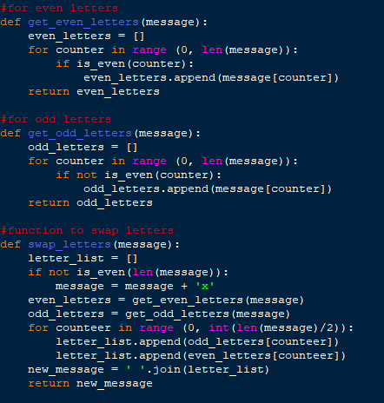

**Assignment Description:**

This program is called the Secret Messages Assignment. The purpose of this code is to encrypt and/or decrypt a message provided by the end user and then output the result. I created this program using the Python coding language, which uses the tkinter and random modules to make this code work. It uses for and while loops, which help it function and be able to encrypt or decrypt a message. This program also uses variables, which allows it to run without errors, ultimately making the program functional.

**Reason for including this Assignment in My Portfolio:**

The Secret Messages Assignment program shows that I know how to program in Python, using all of its different functions. This allows me to be able to make the program be able to encrypt and decrypt a message and be able to output it. This program also shows my ability to use and perform fundamental and advanced programming skills as a programmer. This proves my skills by showing use of modules to accomplish a goal which, in this case, is encrypting and decrypting messages. This is done by me importing modules which show my abilities very well. It also shows I can use other programmers code and elaborate on it for my own code and/or program. To continue to build on this, I plan to continue to study and keep up with trends, and work on personal projects to hone my skills. I can also practice by using different methods to solve the same task and stay versatile.